Computer Networks
Lab 10
Syed Huzaifa Ali
23K-0004
BAI-6A

Task 01:
192.192.192.0/29
Subnet Mask: 255.255.255.248

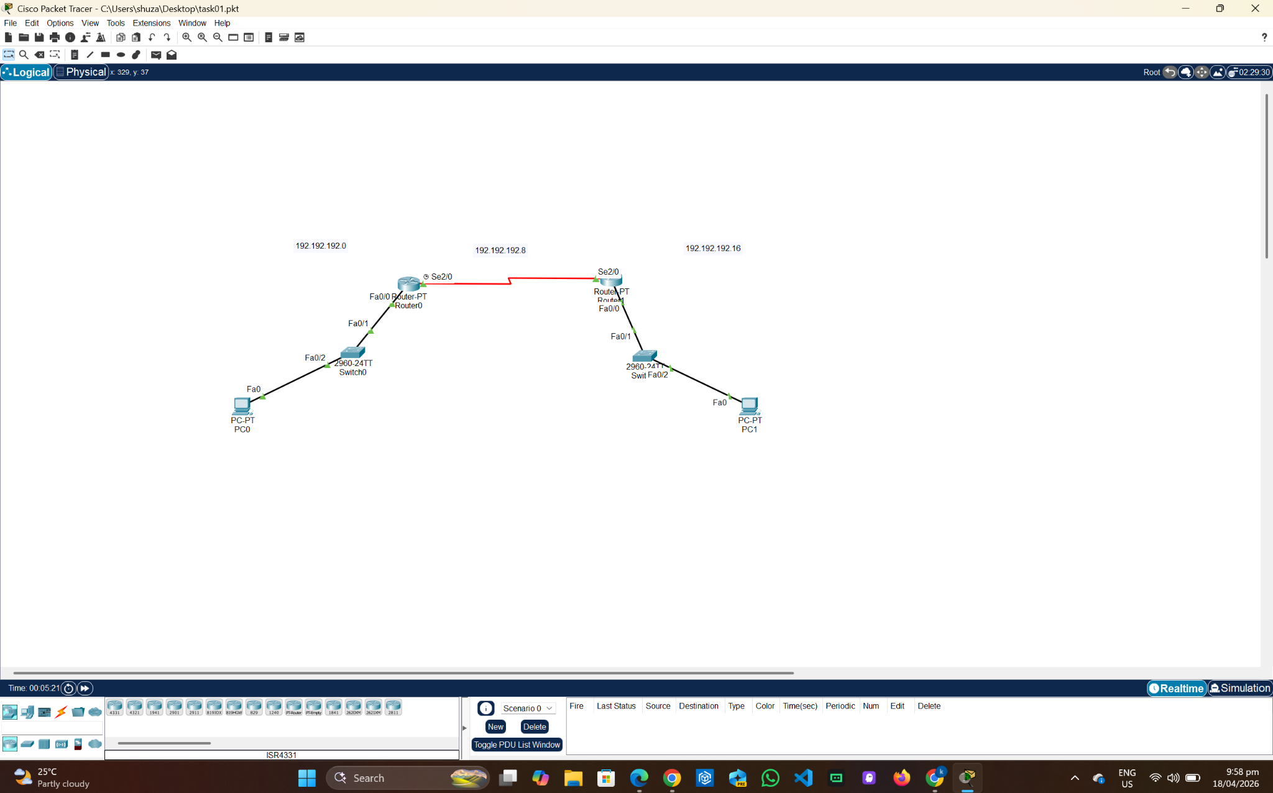

Router 0:
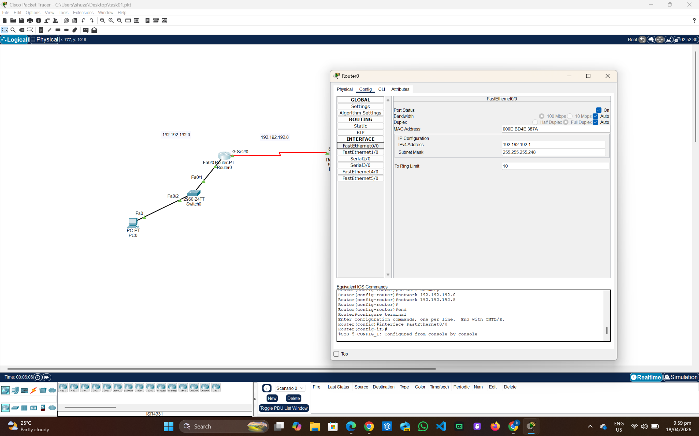
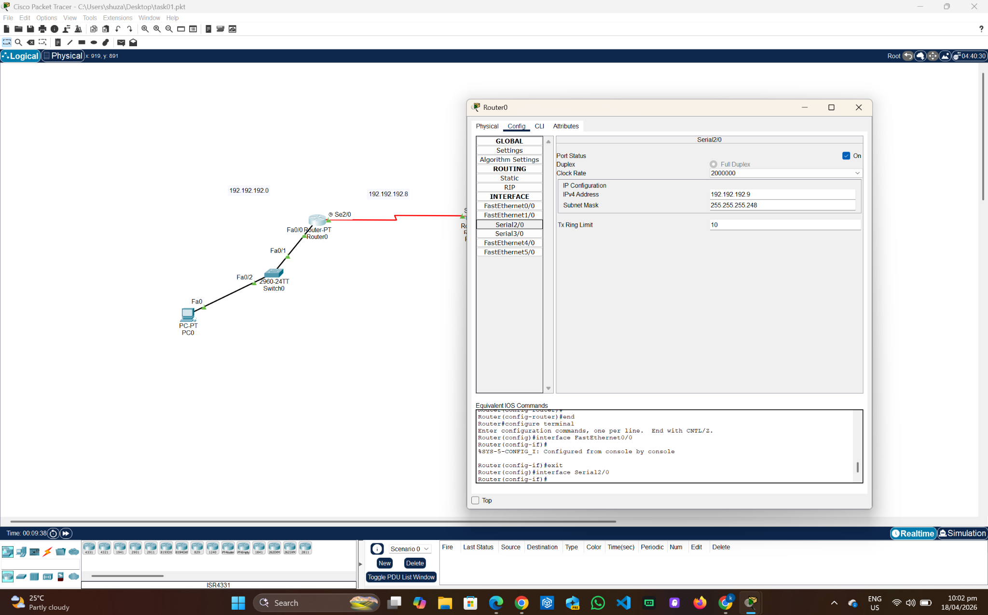
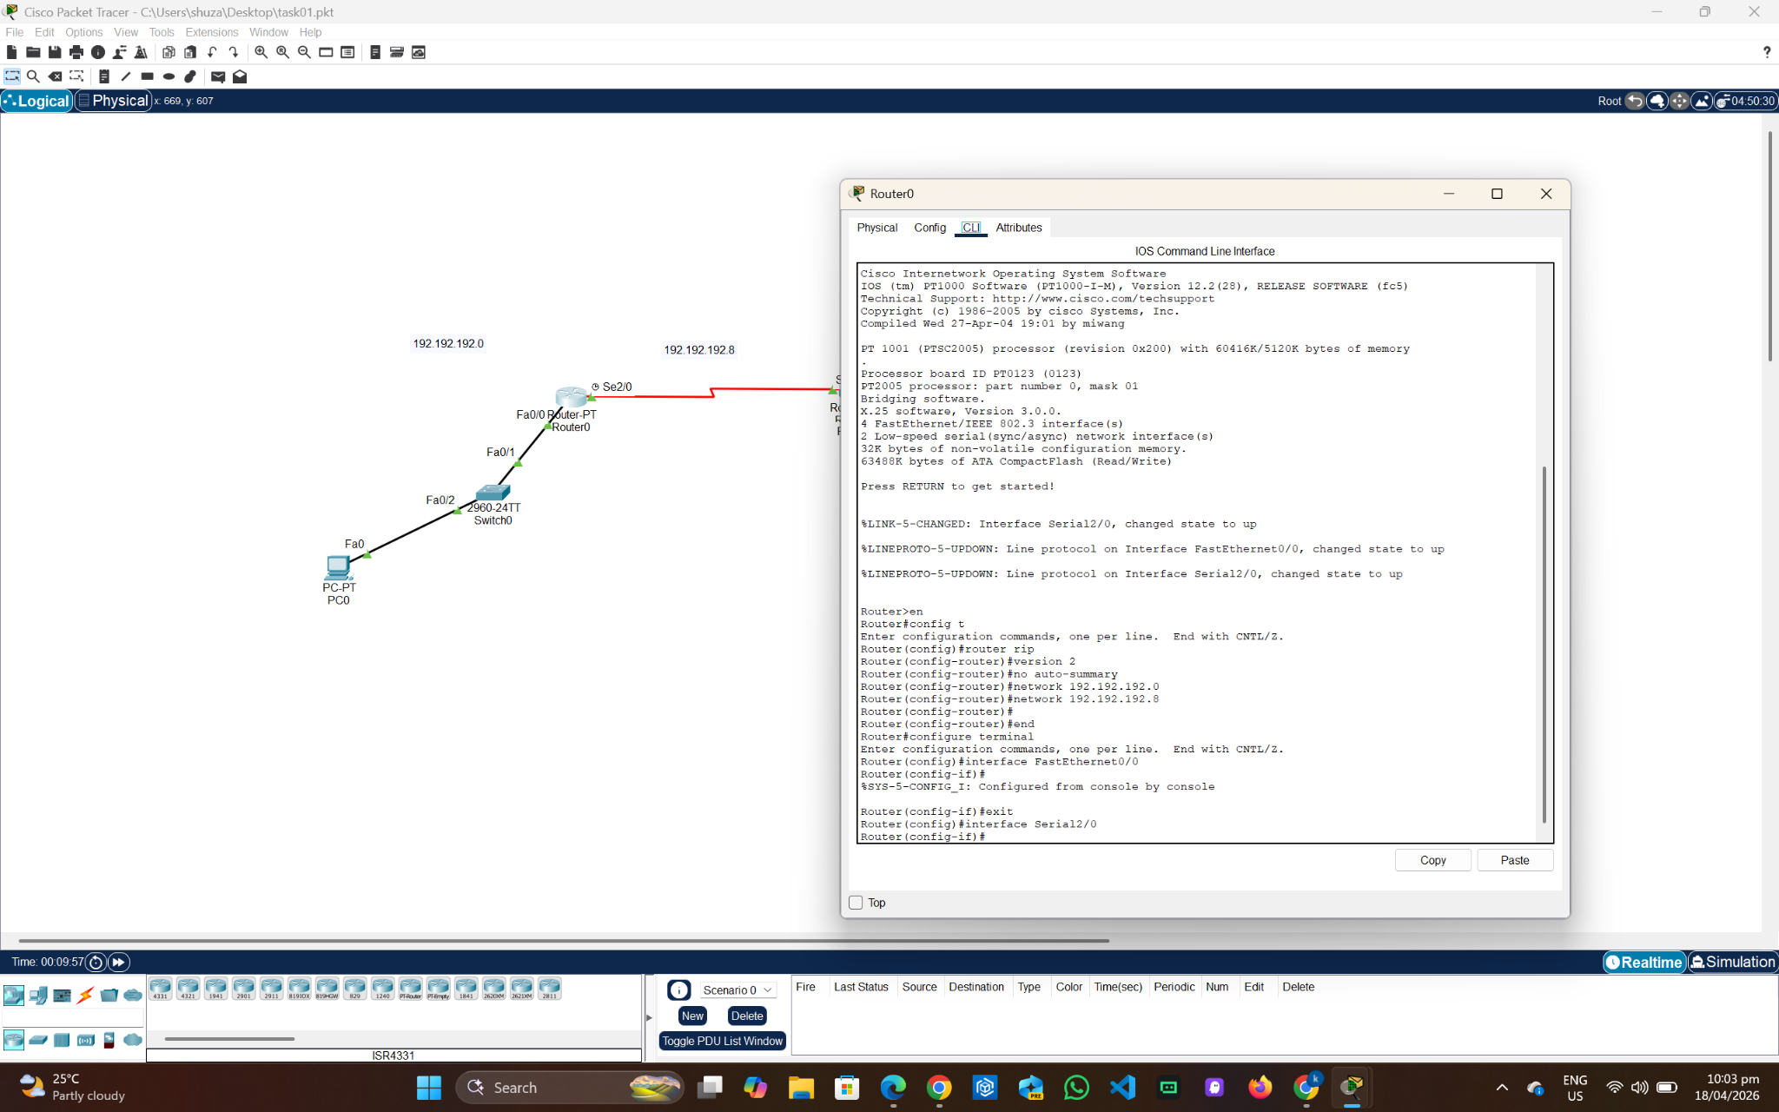

Router 1:
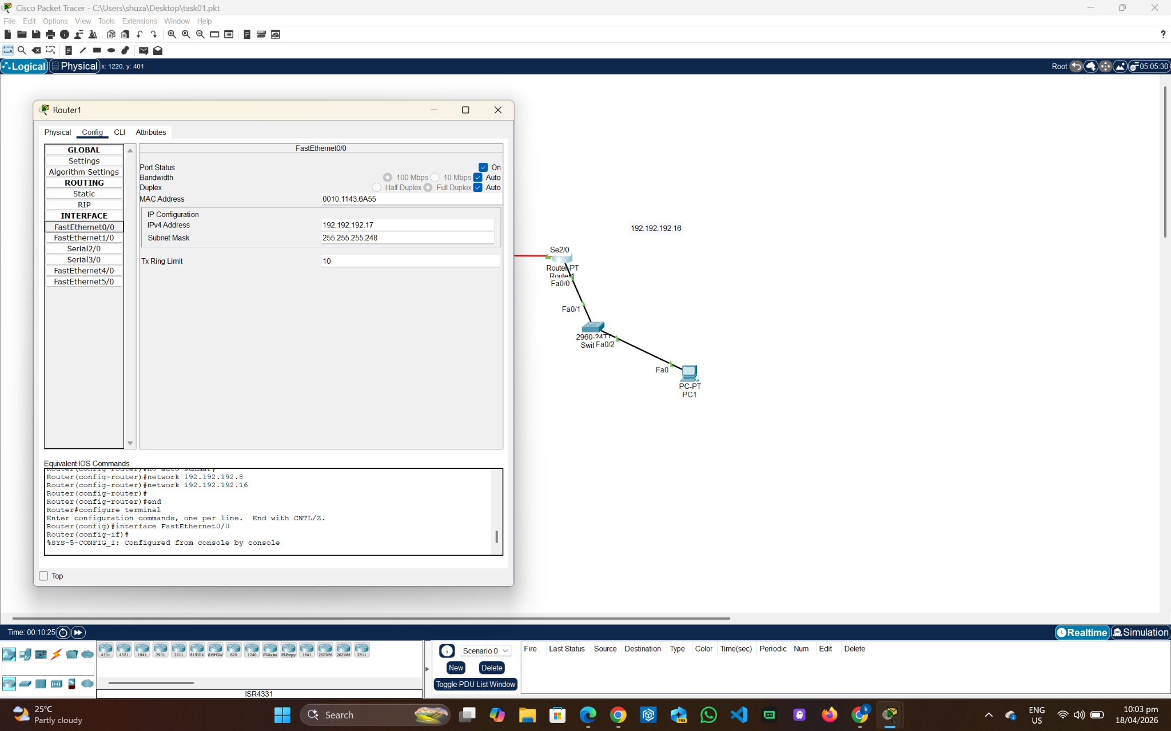
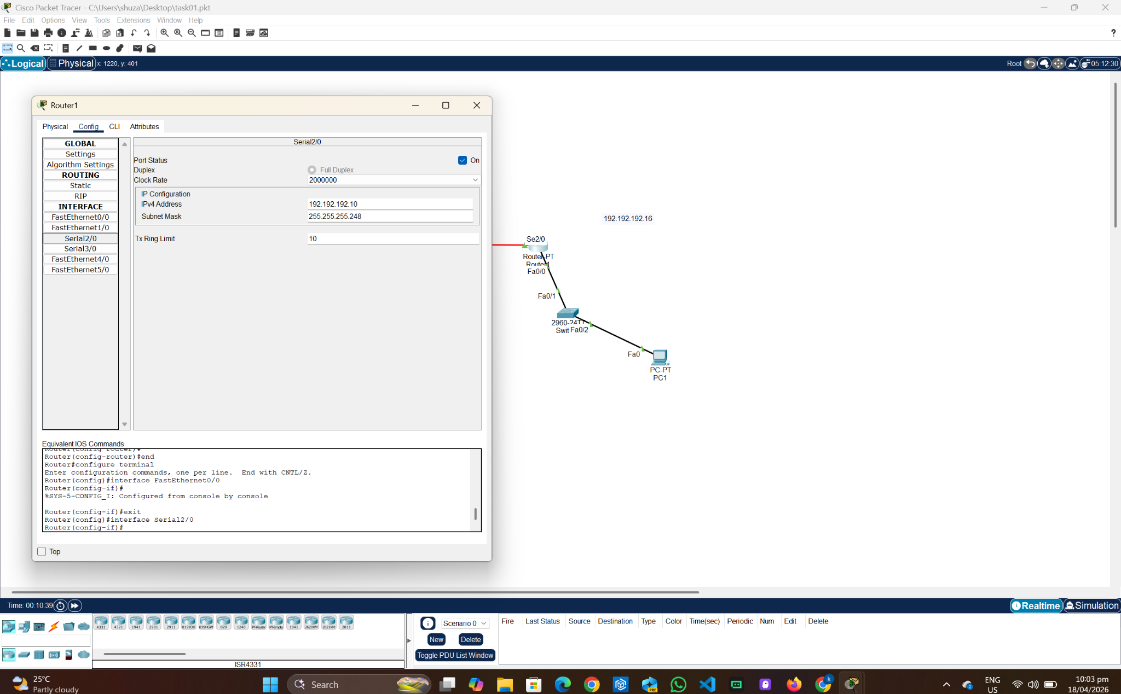
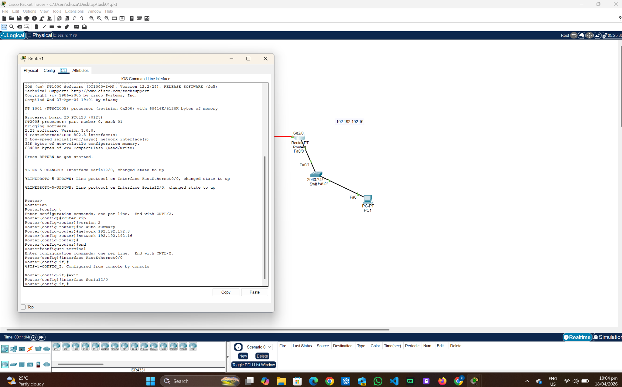

PC 0:
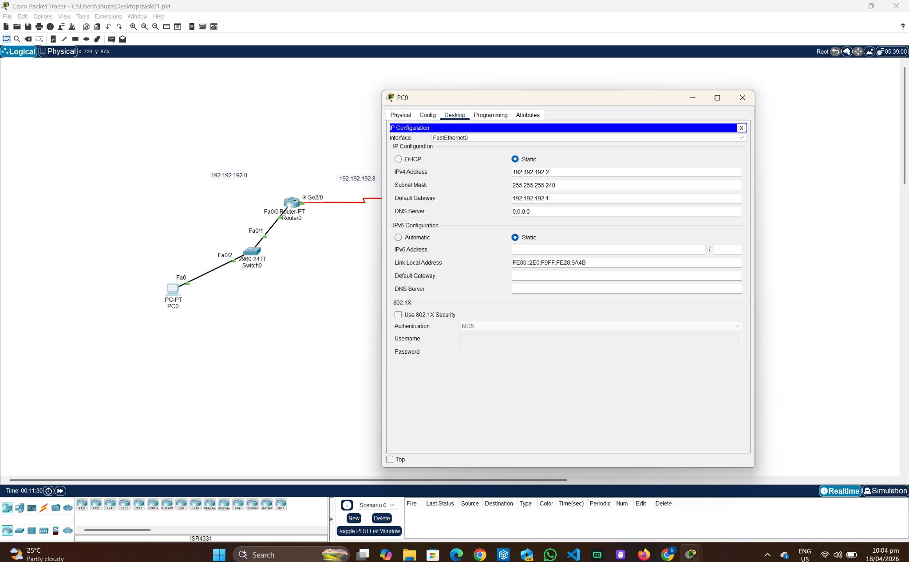
PC 1:
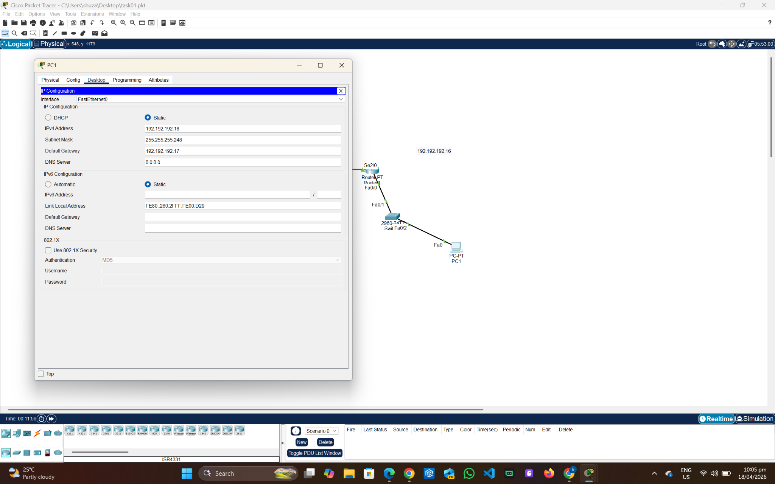
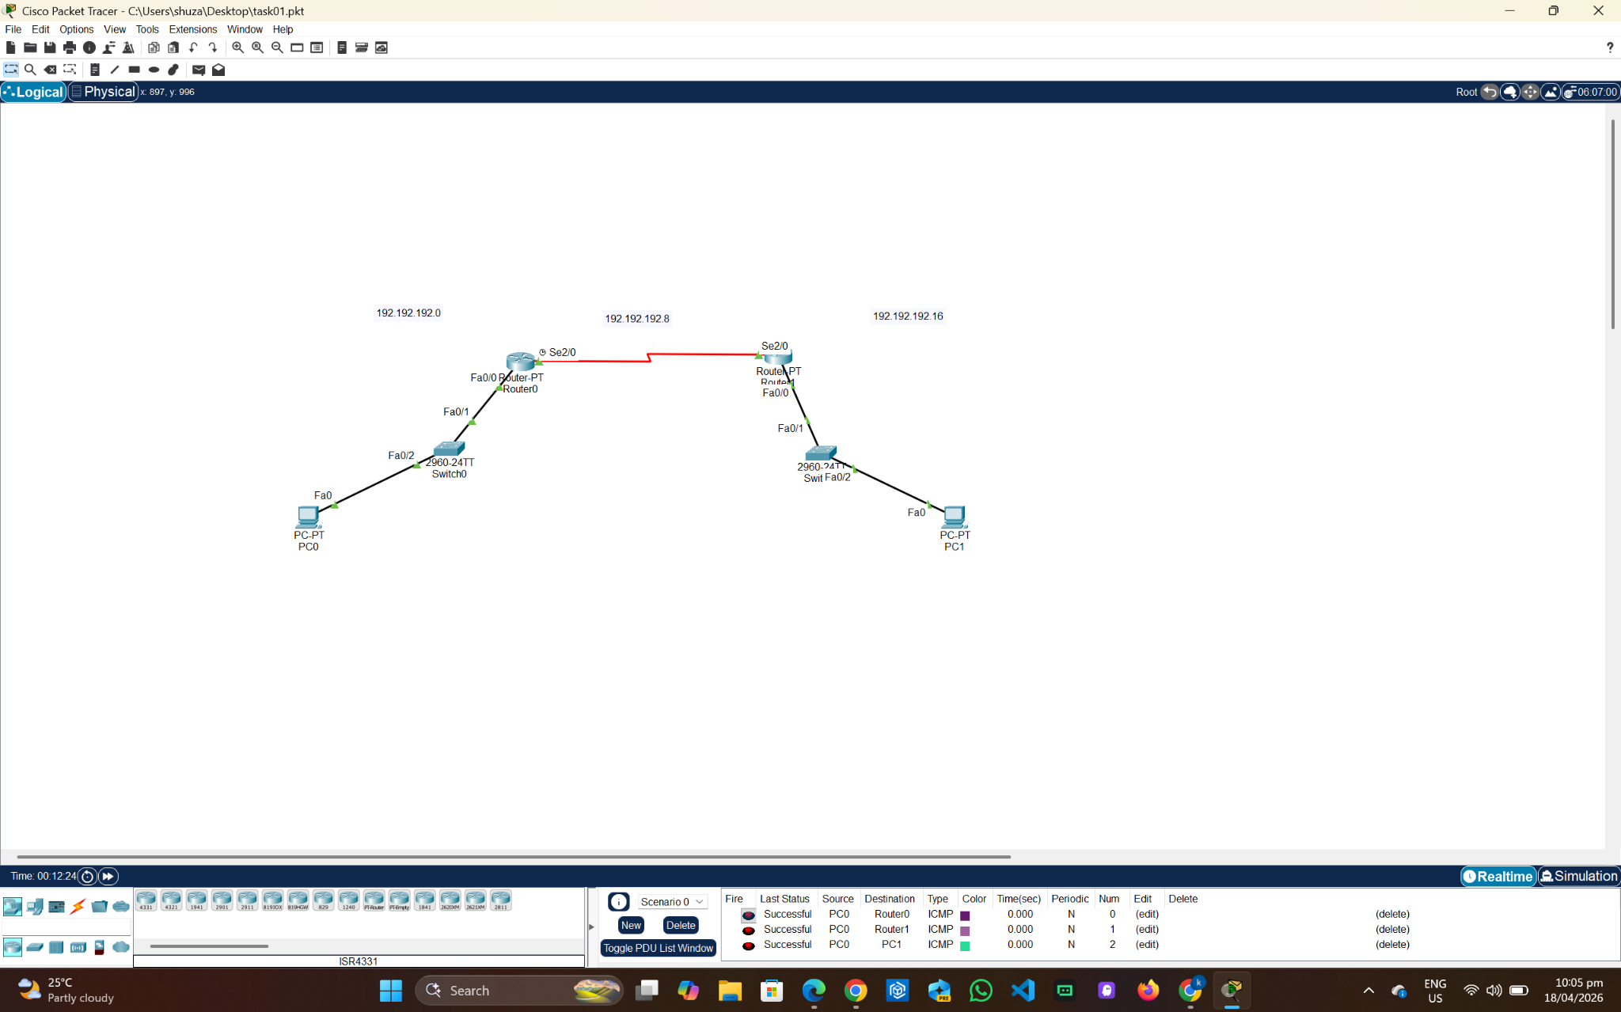

Task 02:
Max hosts: 32
The available ips will be 35 for this network, with 2 as network and broadcast addresses, 1 for the router, and 32 for the hosts. This means that 64 ips should be assigned here, and for the other networks as well considering FLSM (Fixed Length Subnet Mask).

Required bits: 6 -> 2^6 = 64
Borrowed bits: 2 -> 2^7 + 2^6 = 192
CIDR: /26
Subnet Mask: 255.255.255.192

Development: 200.16.100.0 - 200.16.100.63
Finance: 200.16.100.64 - 200.16.100.127
HR: 200.16.100.128 - 200.16.100.191
Task 03:
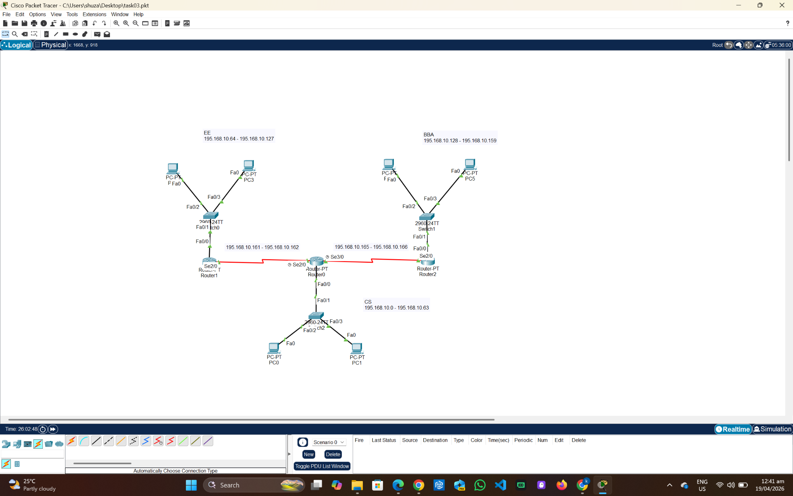
Router 0 (CS):
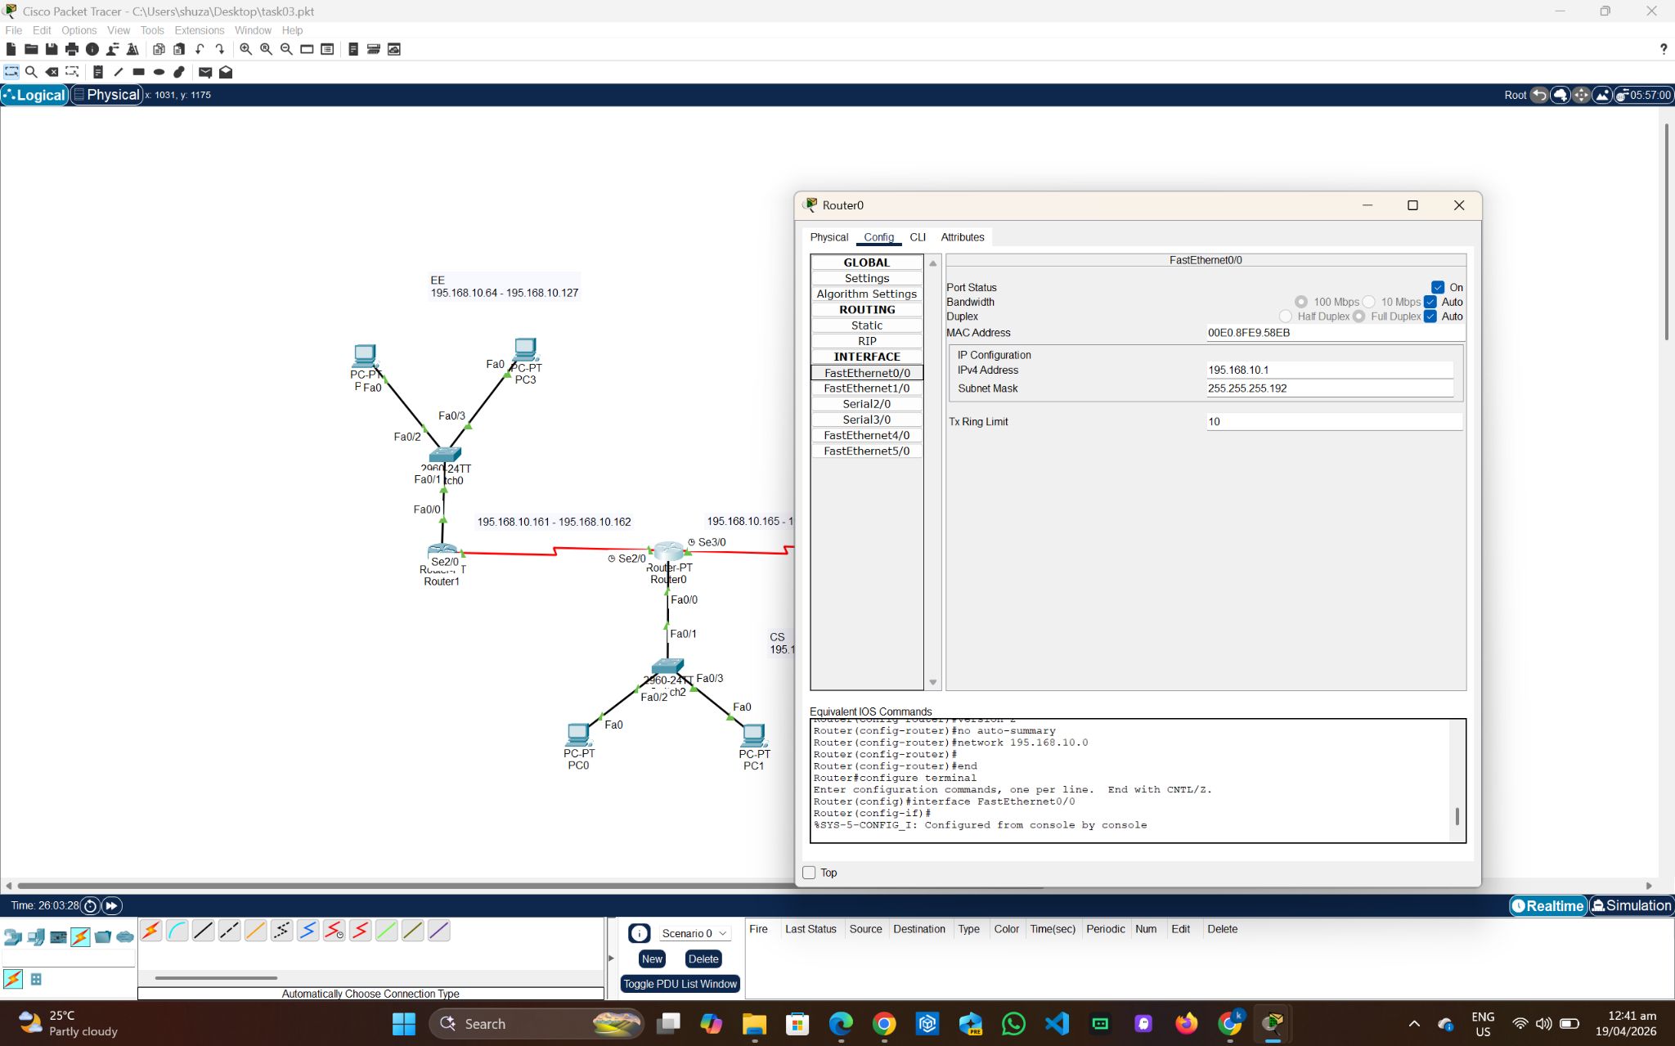
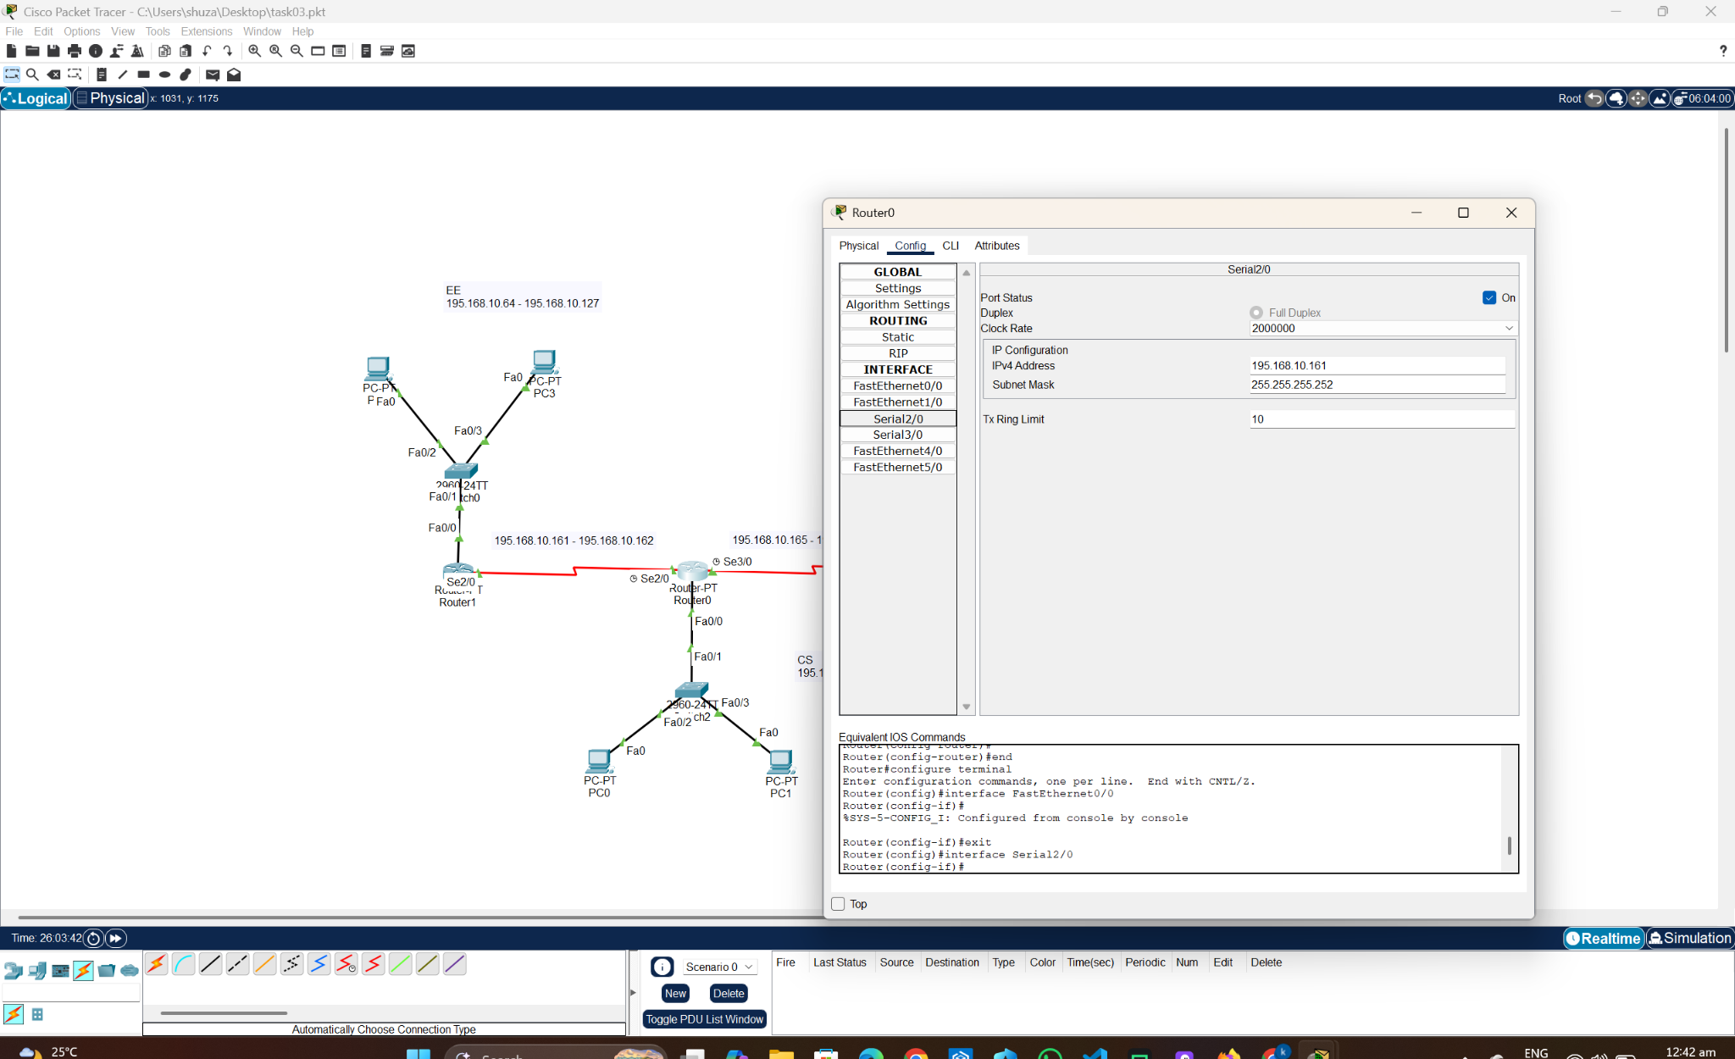

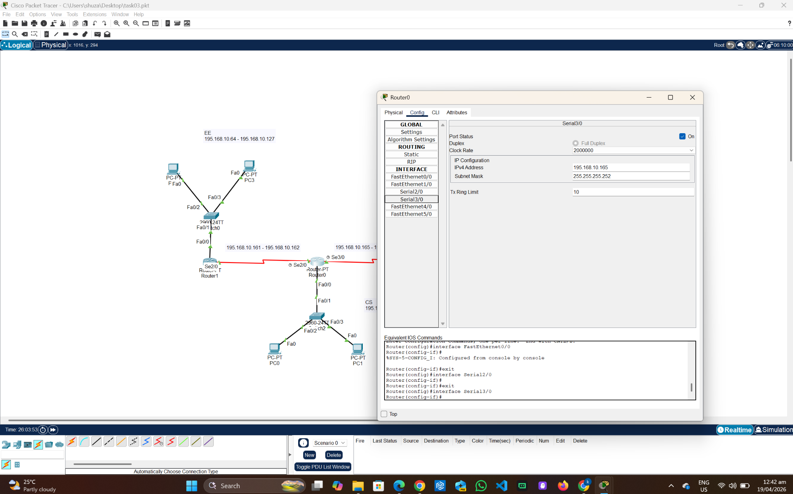

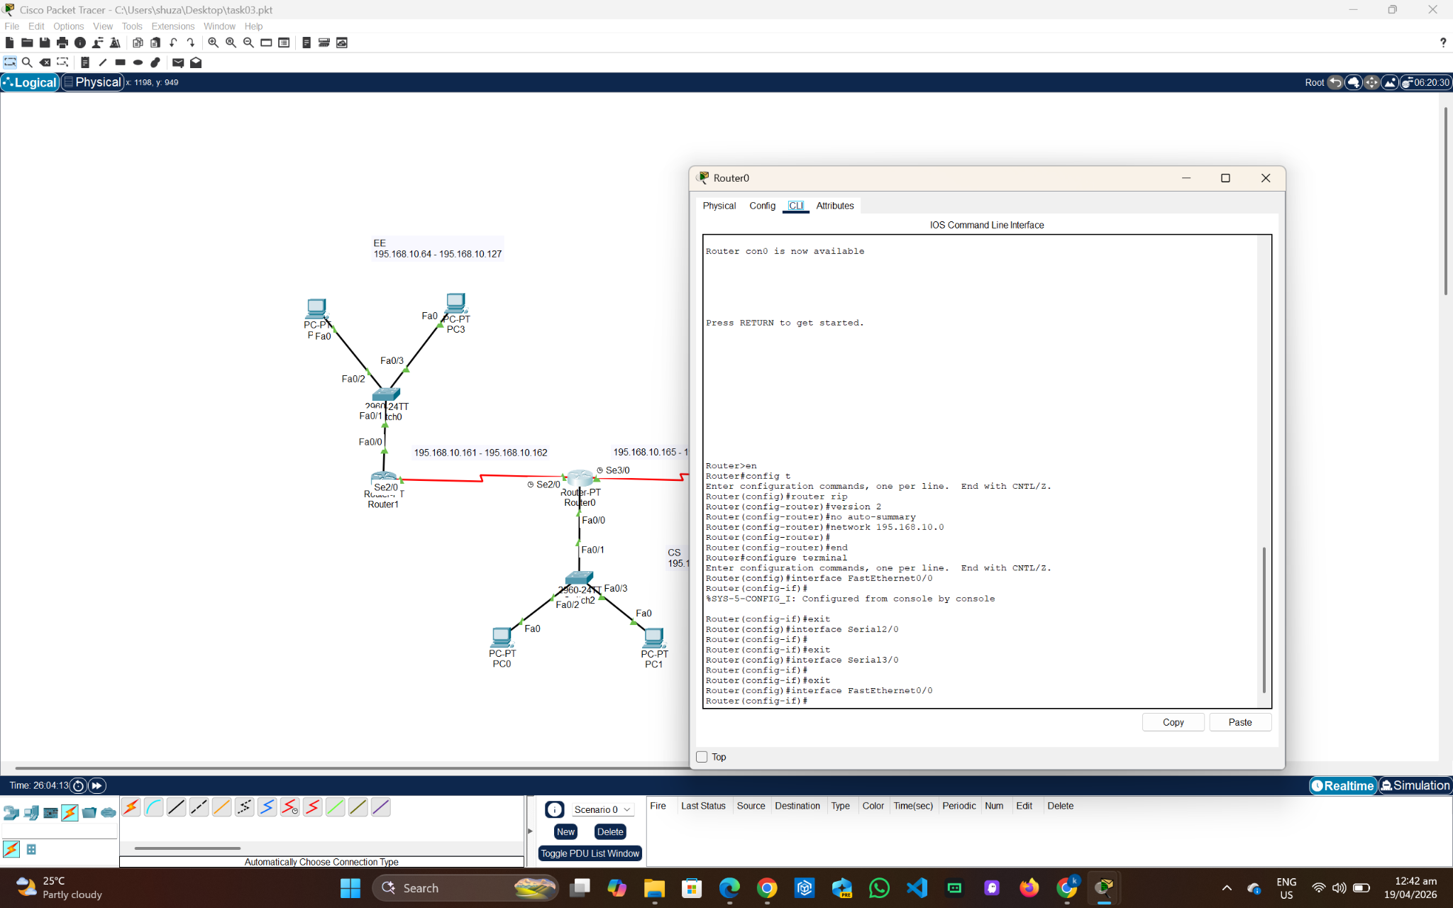
Router 1 (EE):
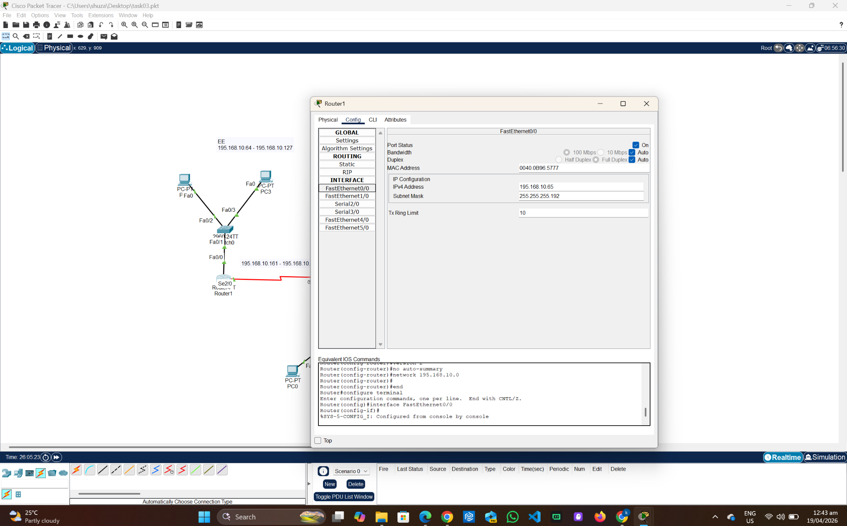

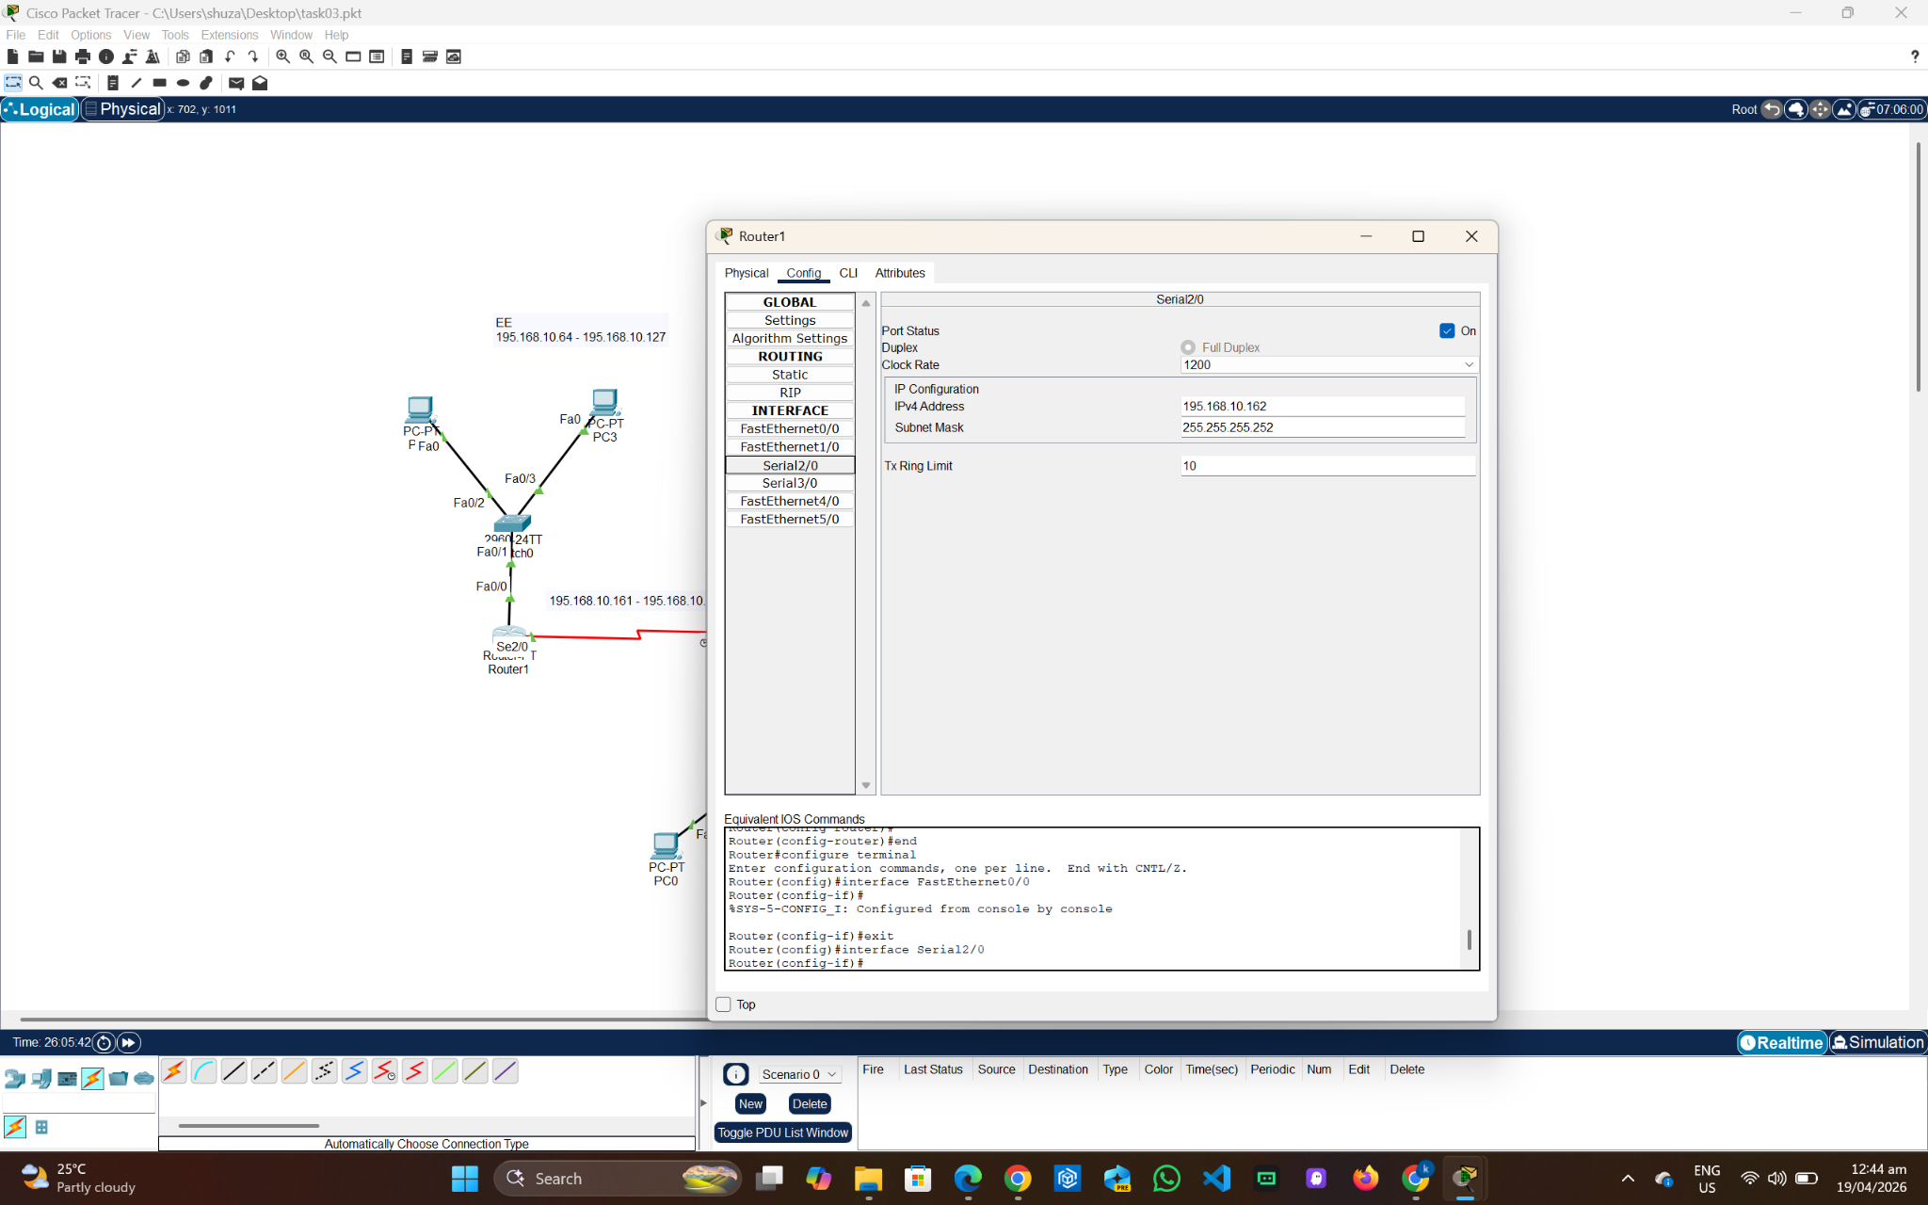

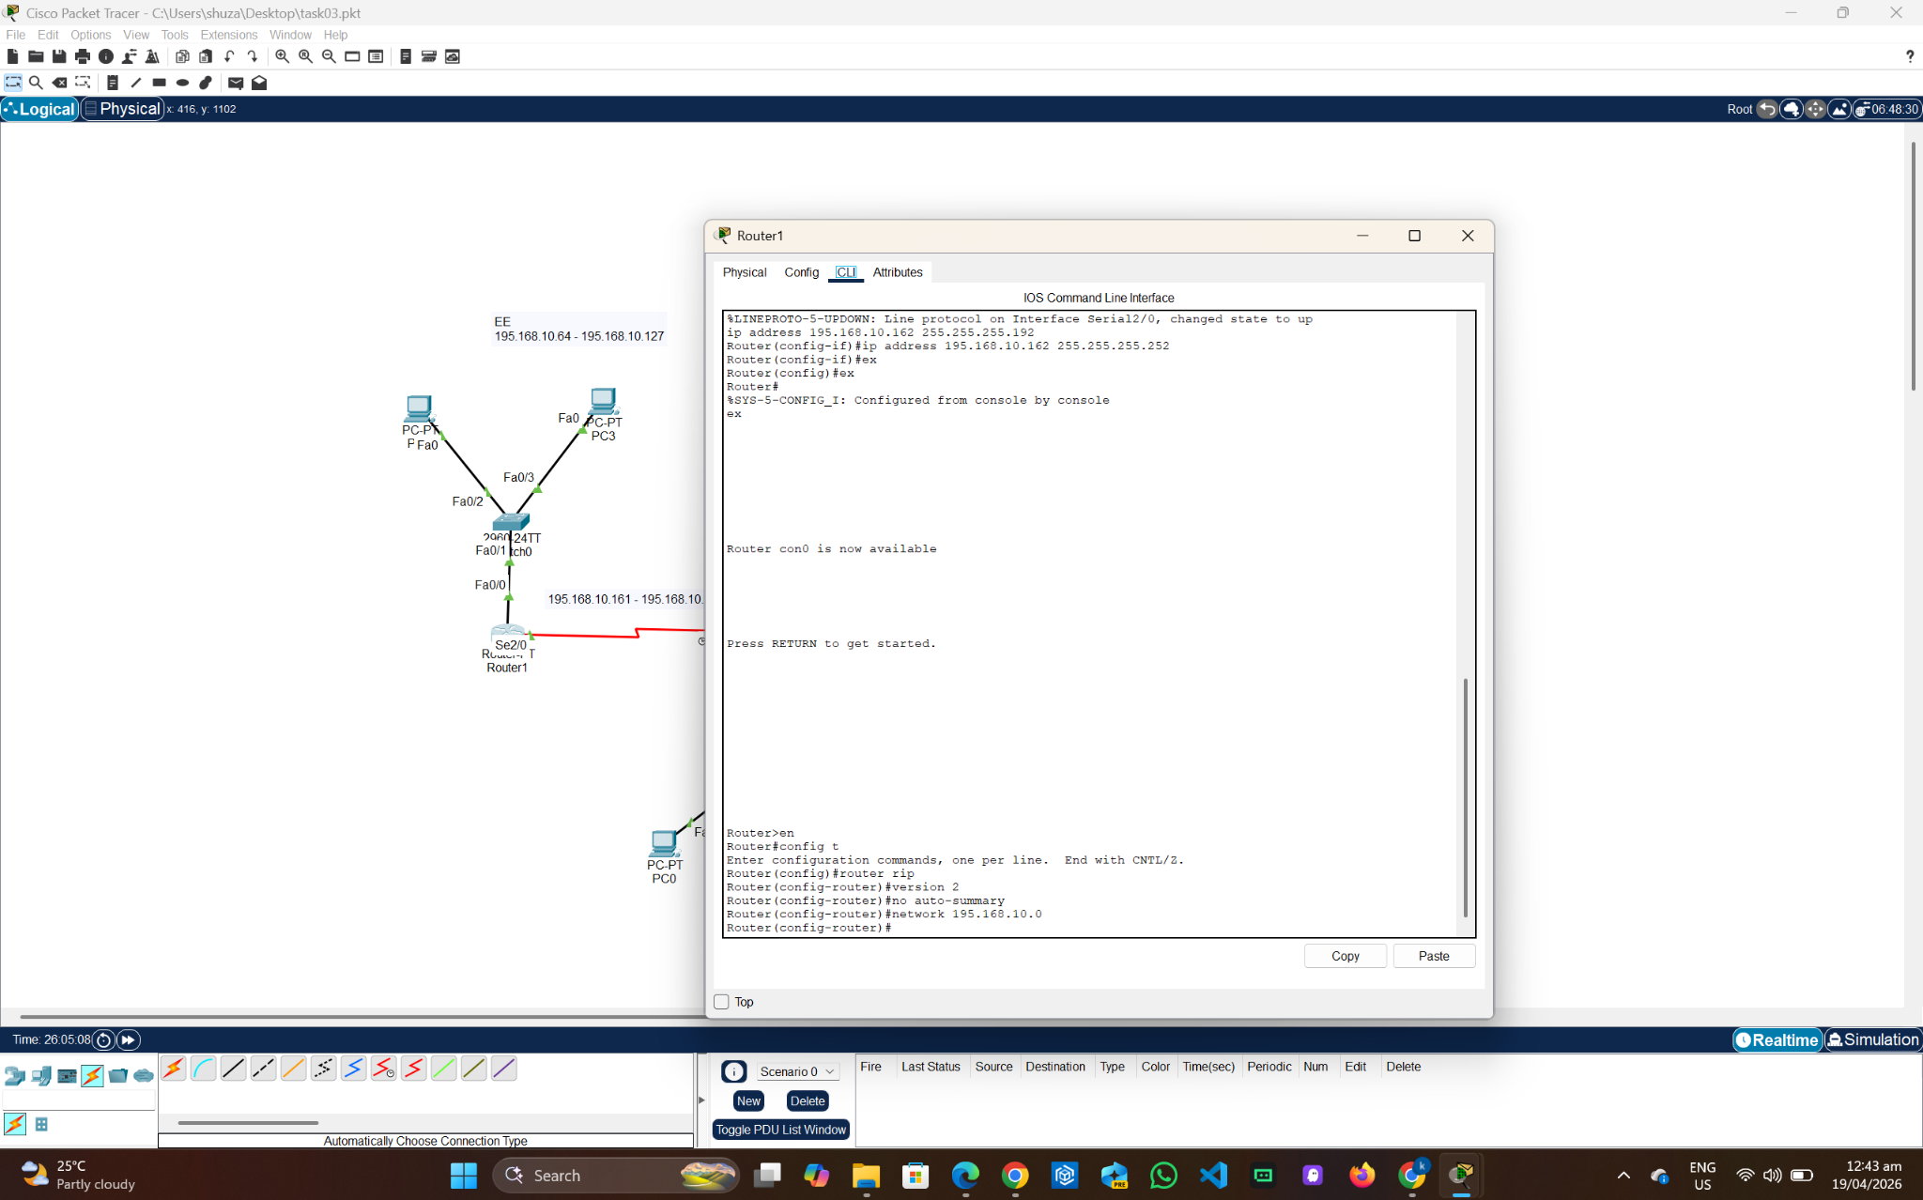
Router 2 (BBA):
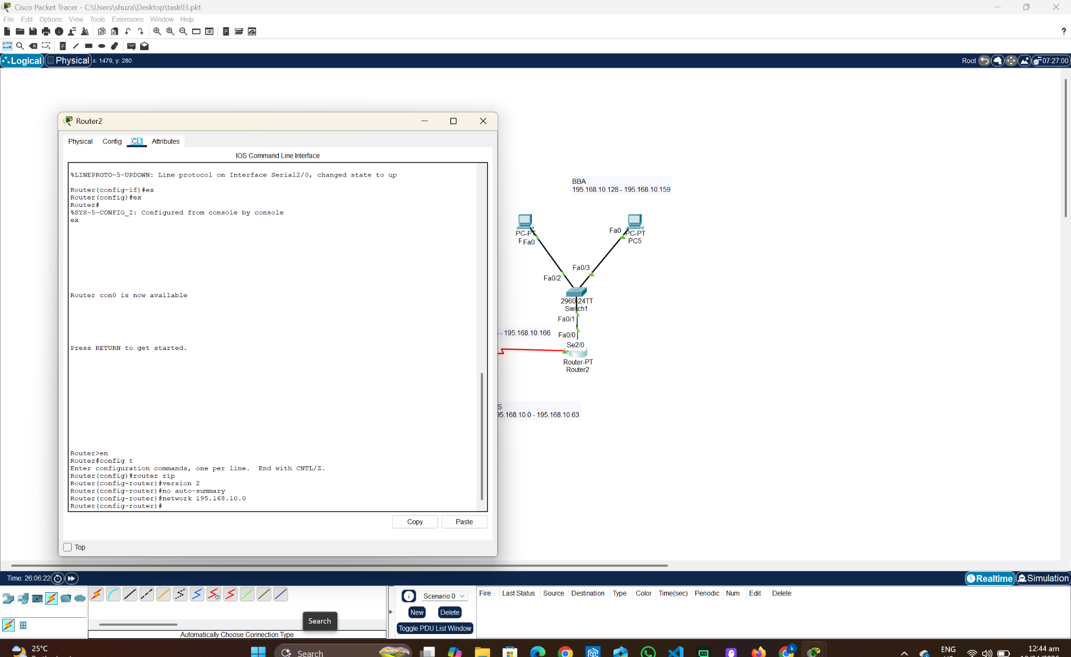

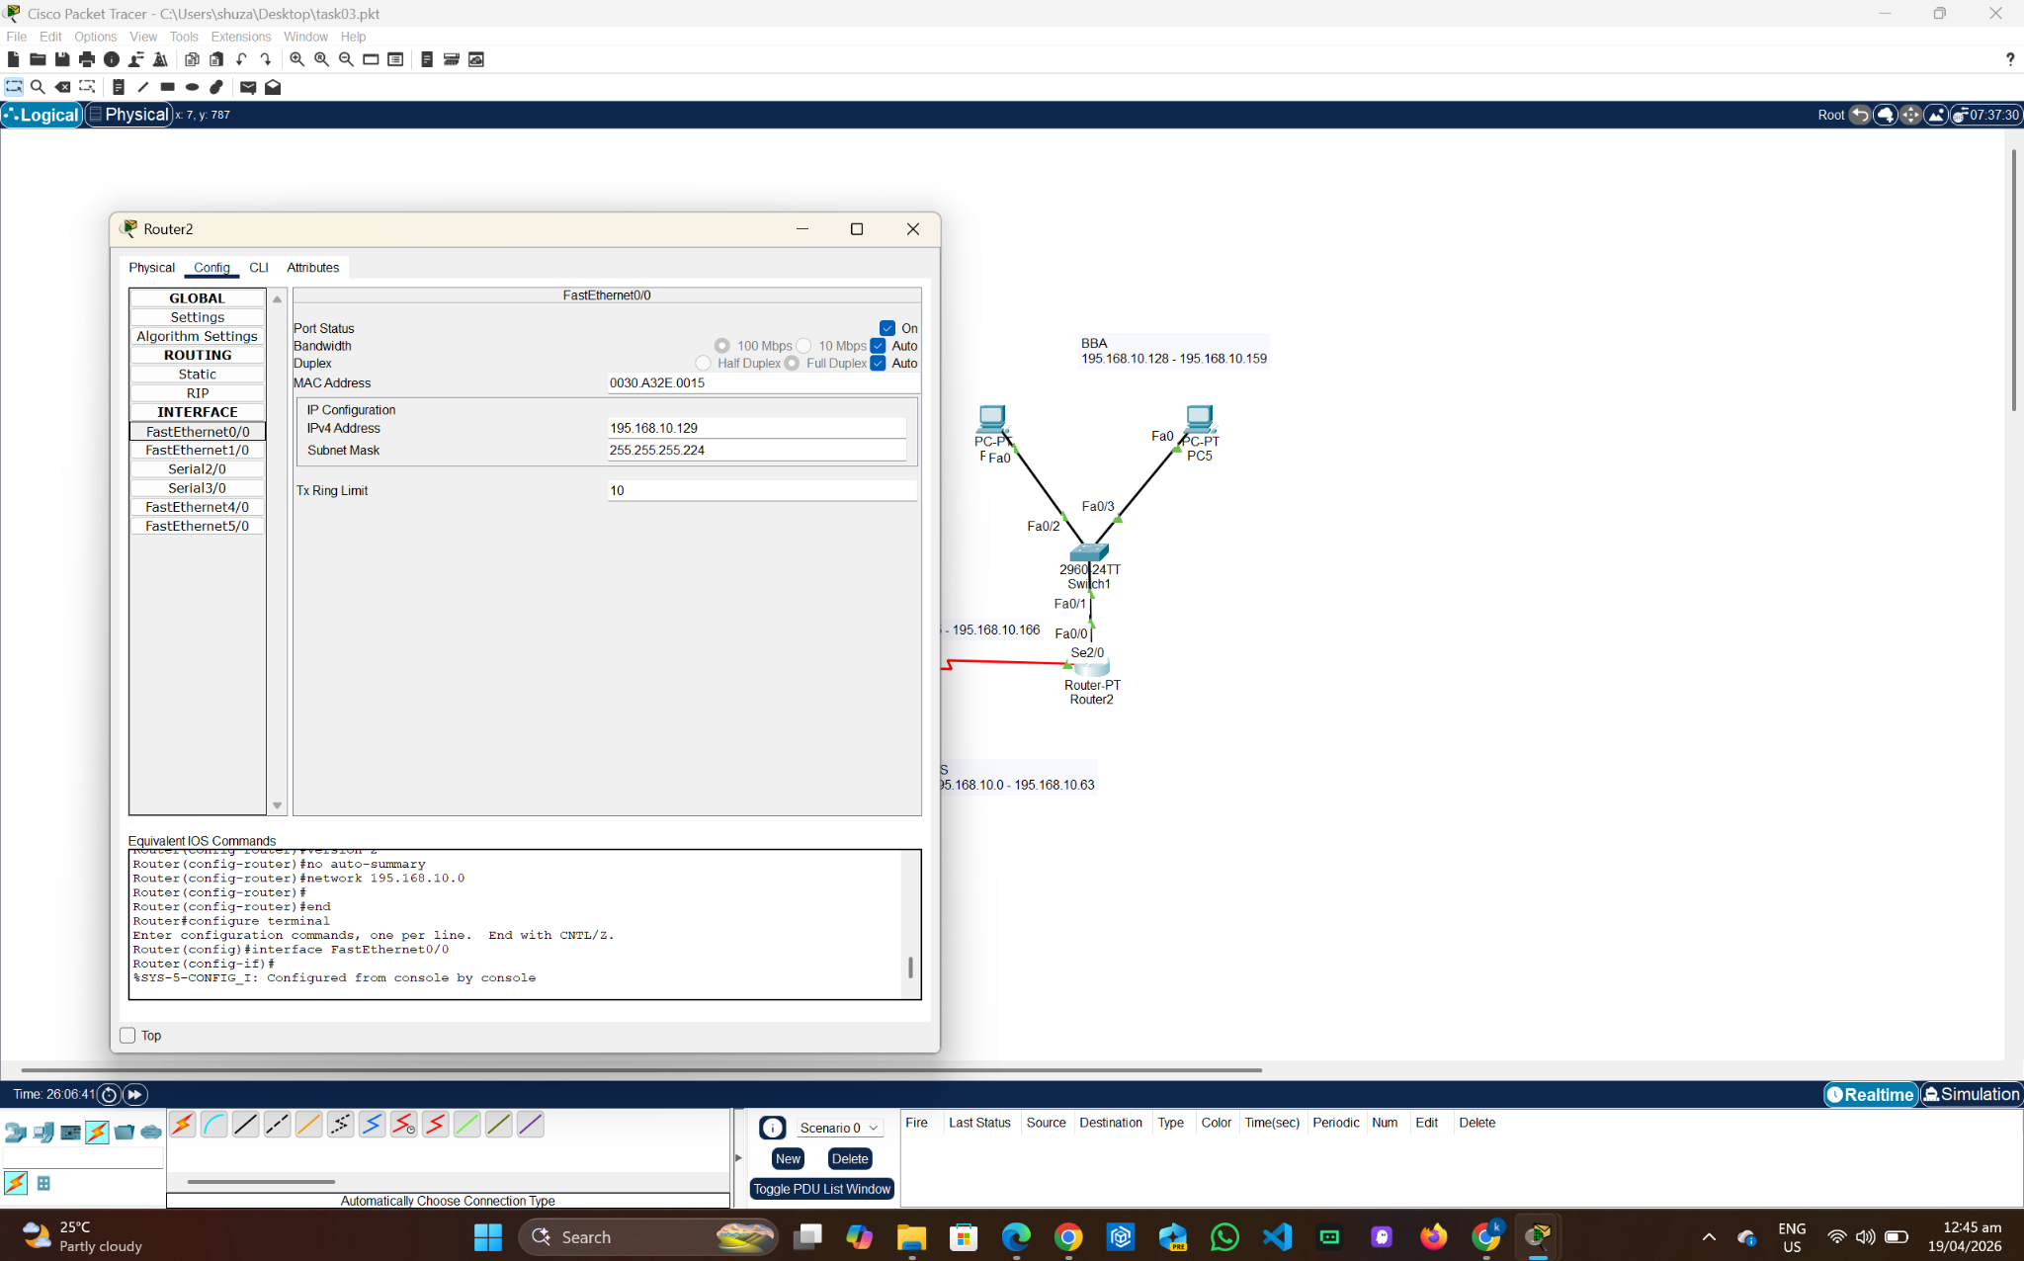
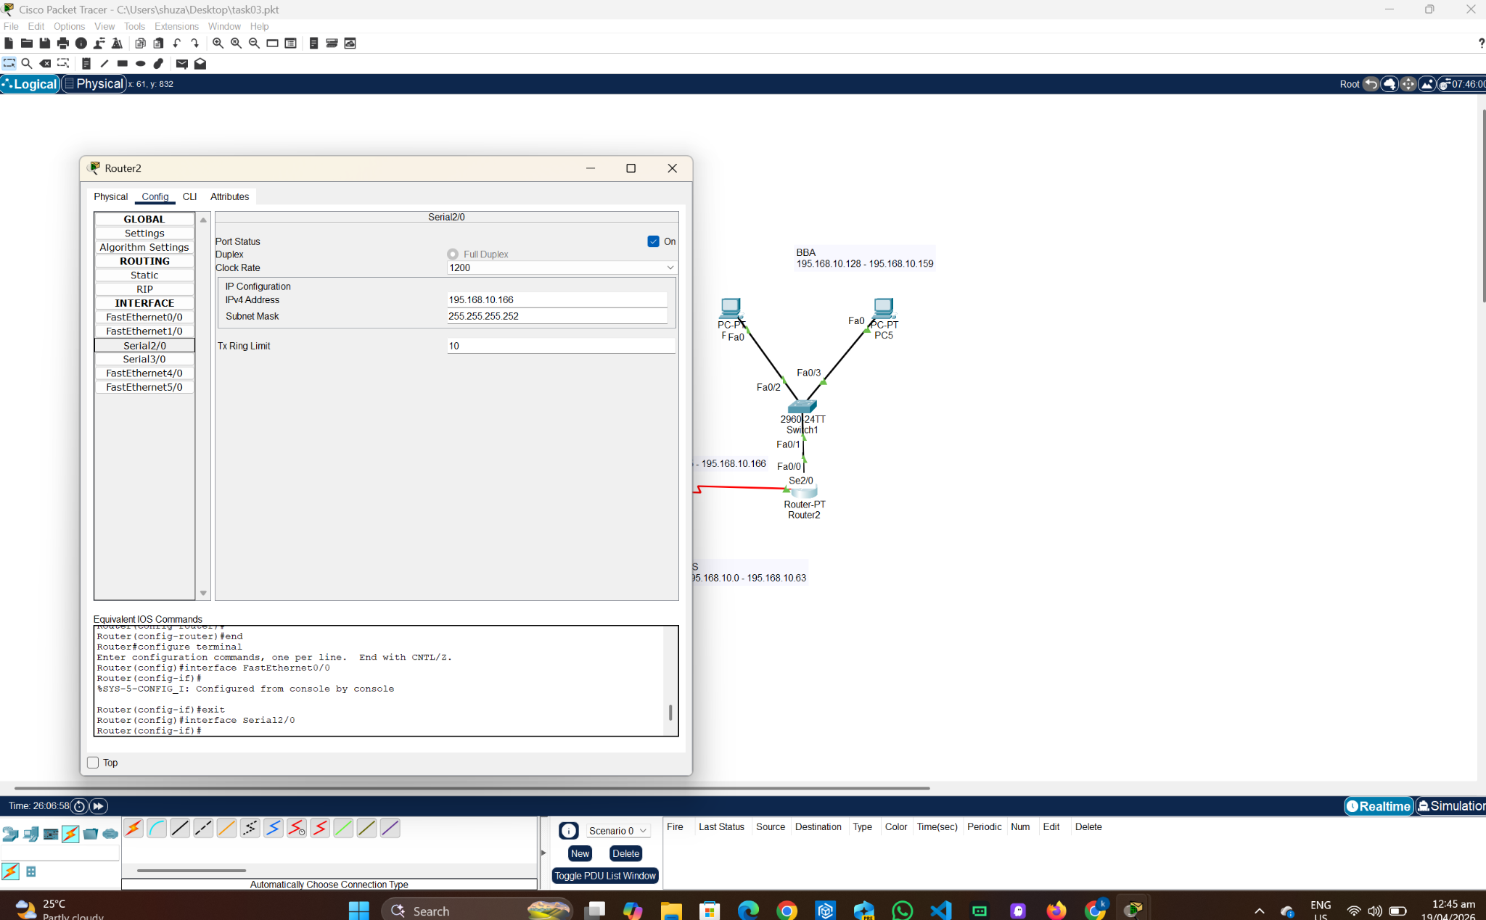
PC 0:
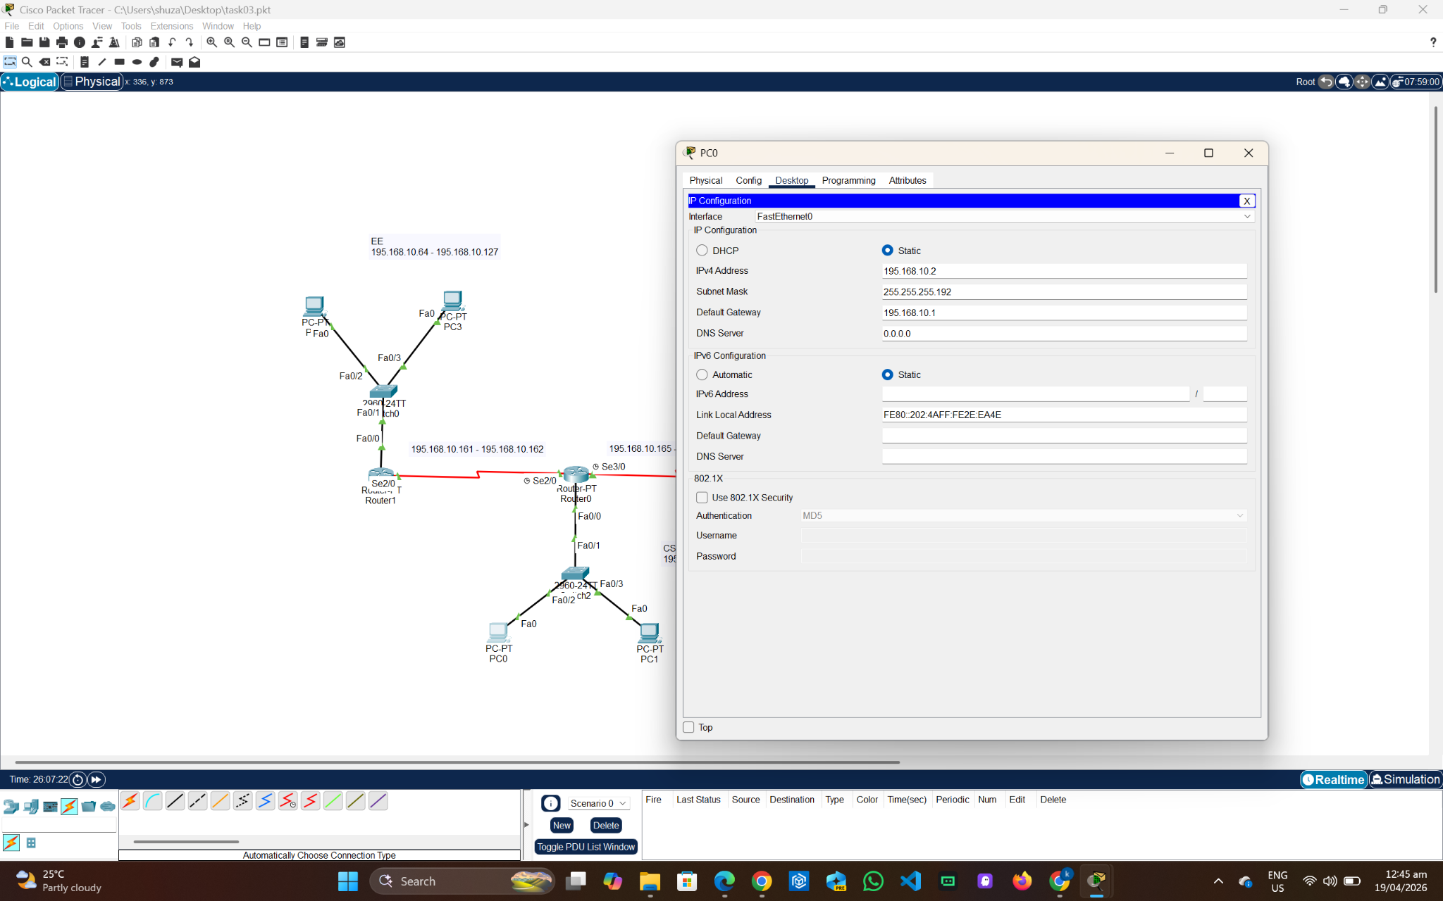

PC 1:
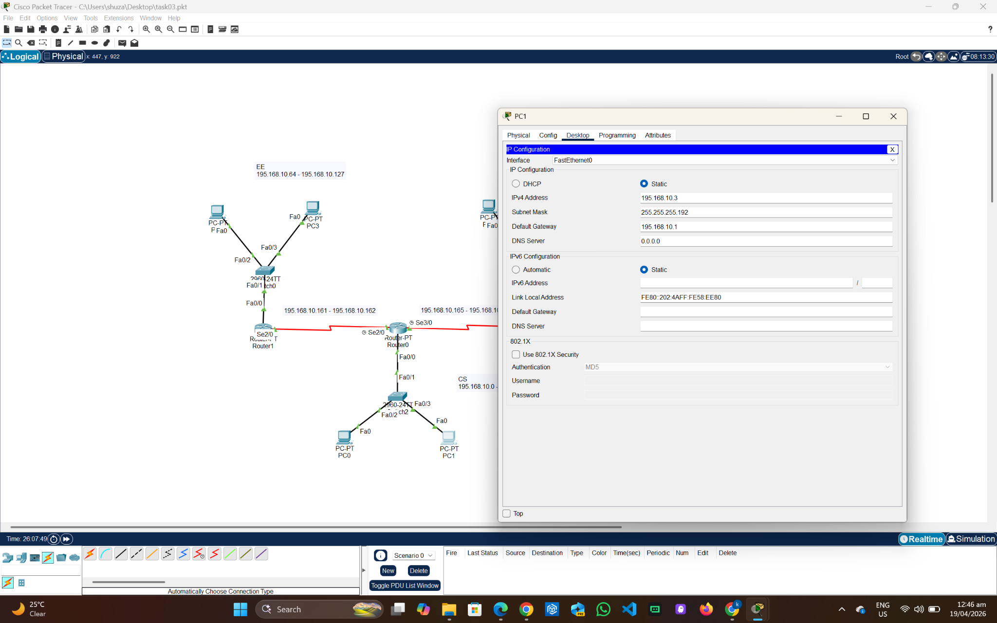
PC 2:
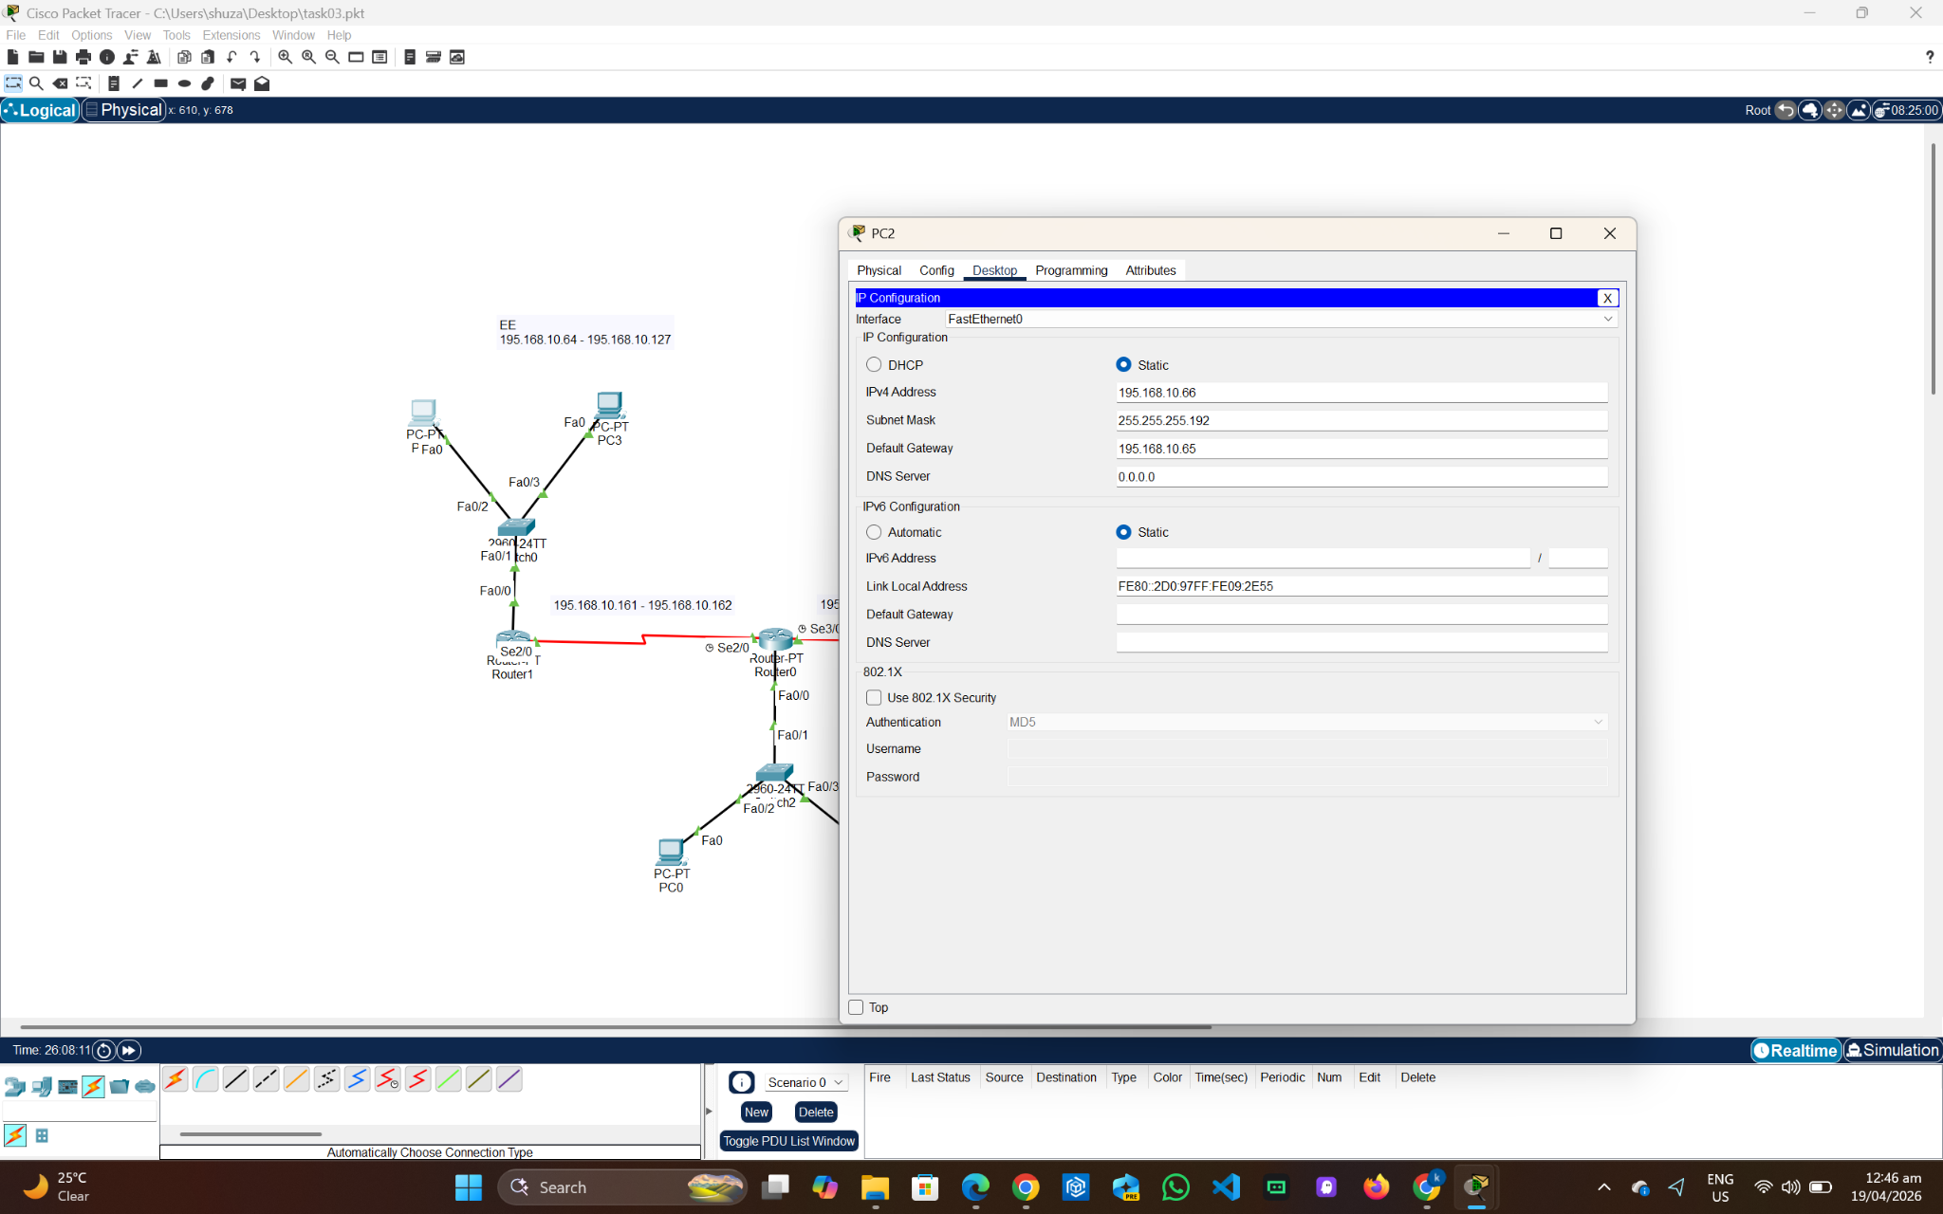
PC 3:
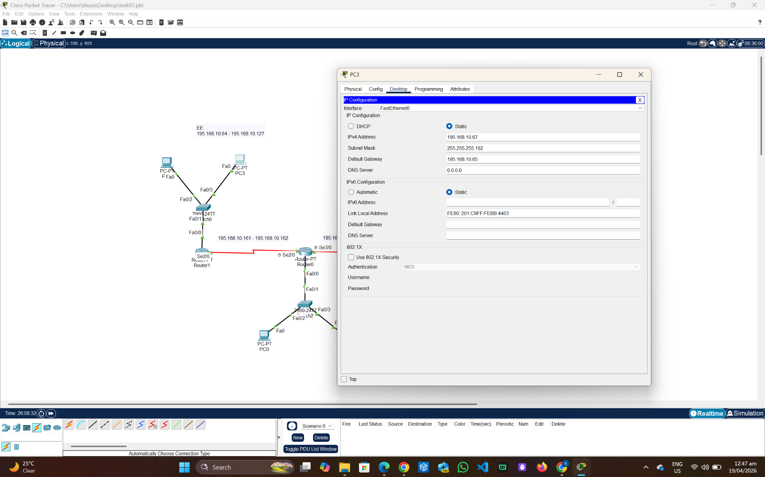
PC 4:
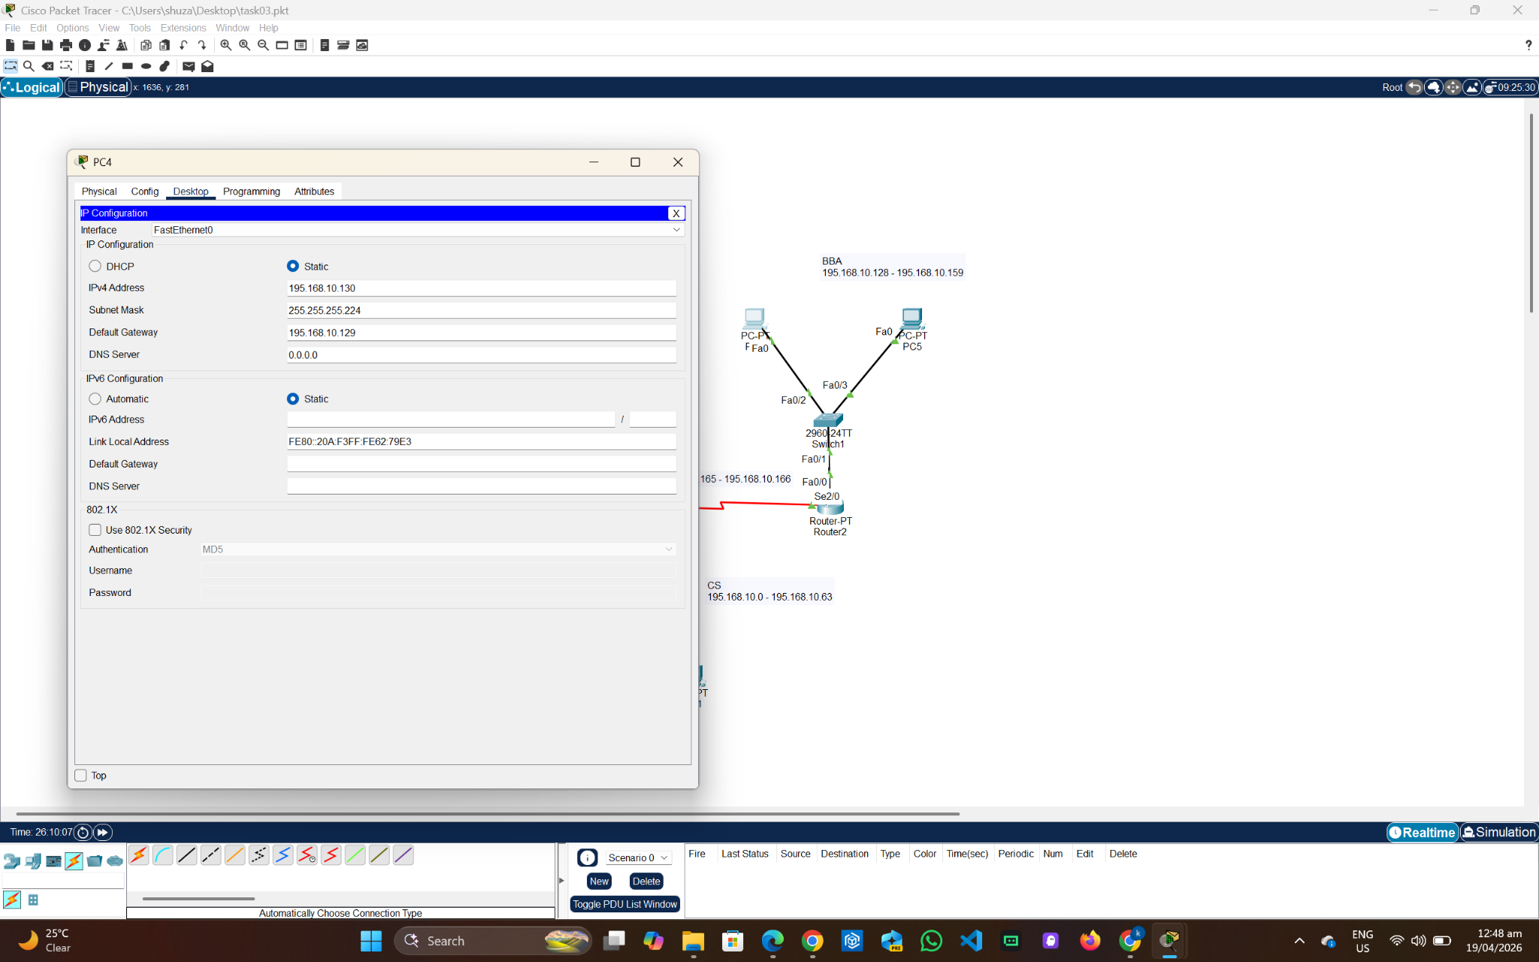
PC 5:
